

**USER MANUAL/DOCUMENTATION**

**System’s Name: Workload Management System**

**NUST Annual Programming competition**

**Group Members:**

|  |  |
| --- | --- |
| **Name** | **Surname** |
| **Augusto** | **Domingos** |
| **Theron** | **Kasita** |
| **Mauro** | **De sousa** |
| **Margareta** | **Ngengongo** |

Table of Contents

Introduction 2

About the System 2

Procedure of Developing Workload System 3

**How to Run** 6

Developing progress 7

Support apps browser 8

# Introduction

This manual is designed to help users quickly get acquainted with the web base system. It provides an overview to the system, and takes you through the various steps involved in processing the application.

# About the System

The Workload Management System is a system that can help a University to manage the tasks progress of the Employees and students. The system has 3 types of system users which are the Admin (HOD and Dean), Lecturer, and Students. The Admin user is those users that has an access to all of the data stored in the database of the system especially on creating and managing system users and other activities. The Lecturers are those users that manage the course and research project details and progress under her/his management such as Students. The Students be able to submit their activities, assignment, and class exercises, which makes the system requires the Lecturers to set up their start and end time range of their work on a certain task and this data will be calculated in the report as research project students’ tasks duration.

# Procedure of Developing Workload System

the procedure of developing the application is about the steps that were taken to develop the system and also we focused on the platform that were used to develop the apps.

1. The platform or tool used to develop this system is called: MS VS Code and XAMPP as database/Server
2. PHP and JavaScript as programming language
3. CSS were used to style the pages.
4. Open MS Code, and go to File > New > Create a New Project.
5. We named the application as Workload management system

**Algorithm of Workload management System**

|  |  |
| --- | --- |
| 1. *Start*  *2. Admin login into system go to, 3*  *3. Admin information is stored in the database, go to 4*  *4. Display the dashboard page, go to 5*  *5. Add new faculty and assign the HOD and Dean, go to 6*  *6. Save the added data with its respective HoD and Dean user, go to 7*  *7. Admin add new (courses) teaching load, go to 8*  *8. Create new course, go to 9*  9. *Assign the lecturer to the respective course go to 10, else go back to 7*  *10. Research allocation*  *11. Add new research project to the list*  *12. Student Assigned to a supervisor on the available lecturers*  13. *Starting the progress of the research project, Is there progress? go to 14, else go to 10*  *14. Admin view the progress of the research project between student and Supervisor, is there progress? If it true go to 15, else go to 10*  *15. Viewing the research project deadline for the presentation*  *16. Is the project ready for the presentation based on the deadline? If it is true, then go to 19, else go to 13;*  *17. Submit to the head of the department, go to 18*  *18. Research project approved by the HOD, true go to 19, else go to 16*  *19. Submit to committee, committee set the date for the presentation*  20. Is it the result positive? If it is true Go to 21, else go to 13  21. Change status of the progress bar, to “final admission”  22. After the research project option, Admin will view the activities on the system  23. Admin will view the progress of the courses,  24. *Admin will be able to view progress of each lecturer, HOD and Dean;*  25. *The Admin will be able to view the Student activities and progress on each task*  26. *Displa The Admin will able to see and monitor all the activities for all the tasks and users.*  *27. The Admin should be able to pull out the report of the system or for specific task.*  *28. ying the total research project assigned to a supervisor, is overloaded go to 10? else proceed to 15*  How it works | */l1. ogging stage begins (the admin enter the valid credentials)*  */32. display the admin page on the system*  */4 3. Showing menu tabs and click on the faculty tab*  */5 valid information added*  */6 4. pick the HOD and DEAN users form the users table;*  */7 pick form a drop box course list, if the course is not on the list, click on the add new course*  */8 5. created new course*  */16. 0 Lecturer is assigned to a course and admin will add the students who are studying the*  */17. Admin mange research project*  */18. Research project stage begins*  */19. the stated time by university, all details need to be deleted from database, the student will receive the notification of the his/her supervisor*  */110. has the research project viewed and accepted by the allocated supervisor?*   1. *has the proposal been approved by the supervisor*   */112. Research project stage begins*  */113. the stated time by university, all details need to be deleted from database, the student will receive the notification of the his/her supervisor*  */114 has the research project viewed and accepted by the allocated supervisor?*   1. *has the proposal been approved by the supervisor*   , */16 Confirm the progress of the research project*  */16. confirm the progress of progress and deadline of the research project*  */17 after the head of the department of approved the research project, submit it to the faculty committee for the presentation.*  */18 make sure that the student and supervisor receive a notification the date of the presentation.*  */119 test if the proposal has been approved by all*  *20. approval stage of the research project*  *21. After the presentation the student will be notified about the result*  *22. Approved presentations and continue*  *23. Click of the view option for the course*  *24. Click on the view bar for the lecturers*  *25. Click on the view bar for the students*  *26. Click on the button bar of view all activities*   1. *Click on the report bar* |

The Workload Management System users can be only created by admin users. The admin user will be able to create a new faculty, project, tasks, activities and department and also will be able to manage the students and lecturers. When creating a project, the admin must list all the students and lecturers that will handle the tasks. After the creation of the project, the students are limited only to adding their project or activities progress for the task of the project that they are assigned. The lecturers are also allowed to edit the data of the progress that they only submitted.

**Features:**

#### Required features:

* Login form with valid credentials
* Each user on access of data and do depending on work activities to be performed by the user

#### Added feature:

* Automated responses for feed back to students using the system
* Log in details are generated by database, and communicated automatically
* All users will be added by the System Admin
* Progress bar feature for supervisor to view the progress of the research project
* The Dean and HOD can set up the start and end date of the research project.
* Administrators, HOD and Dean can add new users, new course, New project and New faculty.
* System Admin, Dean and HoD can update, Delete the users, project, and faculty
* Lecturer can view the assigned or linked modules to him/her
* Lecturer can view the total number of the students from each module
* The Lecturer can update on the progress of the research project
* Student can view the modules and his/her progress of research project.
* Data Base
* Adjust according to the size of screen

# **How to Run**

* Download the folder code and extract the zip file.
* Download or set up any local web server that runs PHP script.
* Open the web-server database and create a new database name with the same of the Workload Management system.
* Import the SQL file located in the database folder of the project folder
* Open a web browser and browse the project and run it in local host. [http://localhost/ the system Name

# Developing progress

Created files:

1. Firstly, we created two files the database and php database connection file.
2. Then was create the login, logout, index and home php file for the admin.
3. The sidebar, topbar, controller and admin dashboard php files were created
4. Lastly the developer created the additional php files, such as; Add users, List Users, Add faculty, List faculty, view faculty, Manage students, adding, updating and deleting files, Manage Research project, manage lecturers, workload activities and tasks lists.

**Dataflow diagram of Workload Management System**

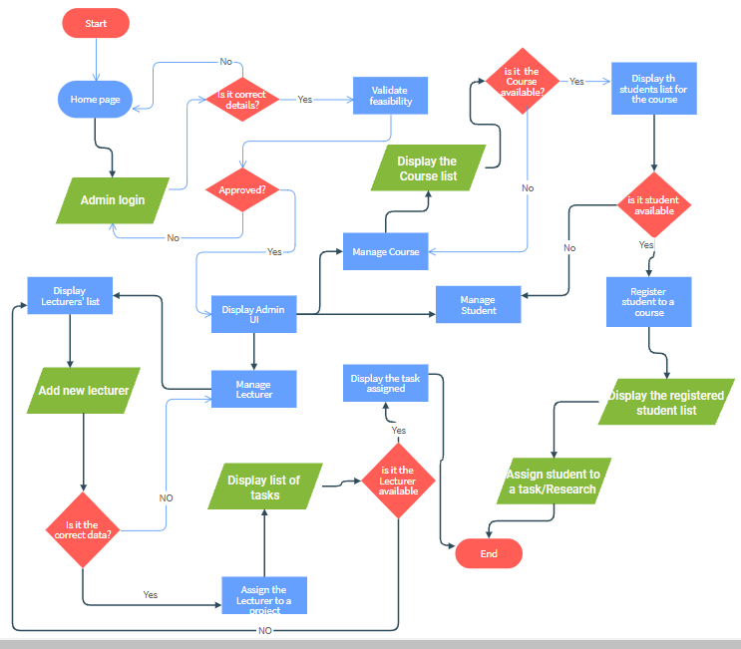

## Support apps browser

the browser required for running and/or downloading the application are:

* Mozilla Firefox
* Google Chrome
* Opera Mini